**University of Computer Studies, Taungoo**



2023-2024 Academic Year

**Digital Alarm Clock based on FPGA**

Fourth Year (Computer Technology)

Digital Design (CT-4132)

**Supervisor- Daw Ei Ei Khaing**

Presented by

Ma Win Lei Lei Khaing(UCSTGO-2836)

Ma Pwint Nay Chi Min(UCSTGO-3469)

Ma Thet Yadanar Htwe(UCSTGO-3004)

Ma Swe Swe Naing(UCSTGO-2934)

**ACKNOWLEDGEMENT**

We extend our heartfelt gratitude to our esteemed teacher, Daw San Ohnmar Kyaw, whose guidance, encouragement, and wisdom have been instrumental in the development of this project.

Throughout our journey, she has provided invaluable support, sharing their expertise, insights, and passion for learning. Their mentorship has inspired us to push the boundaries of our capabilities, fostering creativity, innovation, and a relentless pursuit of excellence.

Teacher’s Daw Moe Moe Htun has not only imparted knowledge but has also instilled in us a sense of perseverance, resilience, and dedication to our craft. Their unwavering belief in our potential has fueled our motivation and fueled our determination to overcome challenges and achieve our goals.

We are profoundly grateful for Teacher's Daw Ei Ei Khaing's unwavering support, guidance, and encouragement. Their commitment to our growth and development as students and individuals has left an indelible mark on our lives and has shaped us into the professionals we aspire to be.

This project stands as a testament to Teacher's Daw Khin Myo Kyi's dedication to education and their unwavering belief in the power of knowledge to transform lives. We are honored to have had the opportunity to learn and grow under their tutelage, and we are forever grateful for their impact on our journey.

**ABSTRACT**

This Project is designed to implement a Digital Alarm Clock on a FPGA (Field Programming Gate Array) using VHDL programming. This digital alarm clock will provide accurate time, alarm functionality and a user-friendly interface. This project also capable of creating a practical and customizable digital alarm clock system. The VHDL code will play a crucial role in defining the clock’s behavior and interactions. This a project that serves both educational and practical purposes, fostering technical skill and creativity in the digital design and FPGA programming.

# TABLE OF CONTENTS

###### ACKNOWLEDGEMENT i

###### ABSTRACT ii

**TABLE OF CONTENTS iii**

**LIST OF FIGURES iv**

1. **Introduction** ………………………………………………..………………………...2
2. **Motivation** ………………………………………………….......………………….…3
3. **Objectives** ………………………………………………………………………….…4

4. **Apply Area** ……………………………………………………………….…………..4

1. **System requirements** ……………………………………………………………..…4
2. **FPGA** ……………………..……………………………….………………………...4
3. **Block Diagram of Digital Alarm Clock**.…………………………………………….5
4. **System Flowchart** …...………………**……………**……………………….…..……..6
5. **Simulation**..………………**…………………………………………………………...7**
6. ****Architecture of Digital Alarm Clock**………………………………………………..7**

**11.** **Advantages and Disadvantages** **…………………………………..……...….……...8**

12. **Conclusion** **……………………...………………………...……….………….……...9**

13. **Further Extension** **…………………………………………...…………...………….9**

**Web Site Lists**

**LIST OF FIGURES**

3.1 Block Diagram of Digital Alarm Clock

8.1 System Flowchart for Digital alarm Clock

9.1 Output Resullt

10.1 Architecture of Digital Alarm Clock

10.2 Architecture of Digital Alarm Clock for hour

10.3 Architecture of Digital Alarm Clock for minute

1. **INTRODUCTION**

A digital alarm clock is a ubiquitous household device designed to display and manage time while also providing alarm functionality to wake users at specified times. Unlike traditional analog alarm clocks, digital alarm clocks utilize electronic components and often incorporate features such as LED or LCD displays for time visualization, customizable alarm settings, and additional functions like snooze buttons and built-in radios.

The core functionality of a digital alarm clock revolves around its ability to accurately track time and trigger alarms at predetermined intervals. Typically, users can set the current time and configure alarm settings using intuitive interfaces, such as buttons or touchscreens. Alarms can be set to activate once or repeatedly at specific times, allowing users to schedule wake-up calls for weekdays, weekends, or other custom intervals.

Digital alarm clocks offer several advantages over their analog counterparts. They provide precise timekeeping through integrated electronic circuits, reducing the likelihood of time discrepancies or inaccuracies. Additionally, their digital displays offer clear and easy-to-read time information, often including features like backlighting for enhanced visibility in low-light conditions.

Furthermore, modern digital alarm clocks may include advanced features such as integrated USB charging ports, Bluetooth connectivity for music streaming, and even integration with smart home systems for seamless control and automation. These features enhance the versatility and convenience of digital alarm clocks, making them an indispensable part of everyday life for many people.

1. **MOTIVATION**

The digital alarm clock project offers an exciting opportunity to delve into the world of digital design and programming, providing a hands-on experience in creating a practical electronic device. By working on this project, you'll not only gain valuable skills in VHDL programming and FPGA implementation but also deepen your understanding of digital logic and electronic circuits.

Moreover, the satisfaction of seeing your code translate into a functional digital clock, complete with alarm capabilities, can be immensely rewarding. Each milestone reached, from designing the clock's architecture to testing its functionality, brings a sense of accomplishment and motivates you to tackle more complex challenges.

Furthermore, the practical applications of this project extend beyond the realm of hobbyist electronics. Digital alarm clocks are ubiquitous in everyday life, and by mastering the skills needed to build one, you'll be equipped to tackle a wide range of digital design projects in the future, whether in academia, industry, or personal pursuits. So, embrace the opportunity to learn, explore, and create something impactful with this digital alarm clock project!

1. **Objectives**

* To ensure precise clock functionality
* To implement a reliable alarm system with customizable setting
* To conduct through simulation of VHDL code

1. **Apply Area**

* The Digital Alarm Clock on an FPGA using VHDL code has abroad range of application areas, including:
* Embedded System
* Home Automation
* IoT Devices
* DIY Electronic Projects

1. **System Requirements**

* Modelsim
* Field Programmable Gate Array (FPGA)
* VHDL (VHSIC Hardware Description Language)

1. **FPGA**

* FPGA stands for Field-Programmable Gate Array.
* It’s an integrated circuit designed to be configured by a customer or a designer after manufacturing, hence the term “field-programmable”.
* FPGAs contain an array of programmable logic blocks, and their interconnections can be configured and reconfigured to implement custom digital circuits.
* They are often used in various applications such as digital signal processing, telecommunication, automotive and many others where flexibility and performance are key.

1. **Block Diagram of the System**

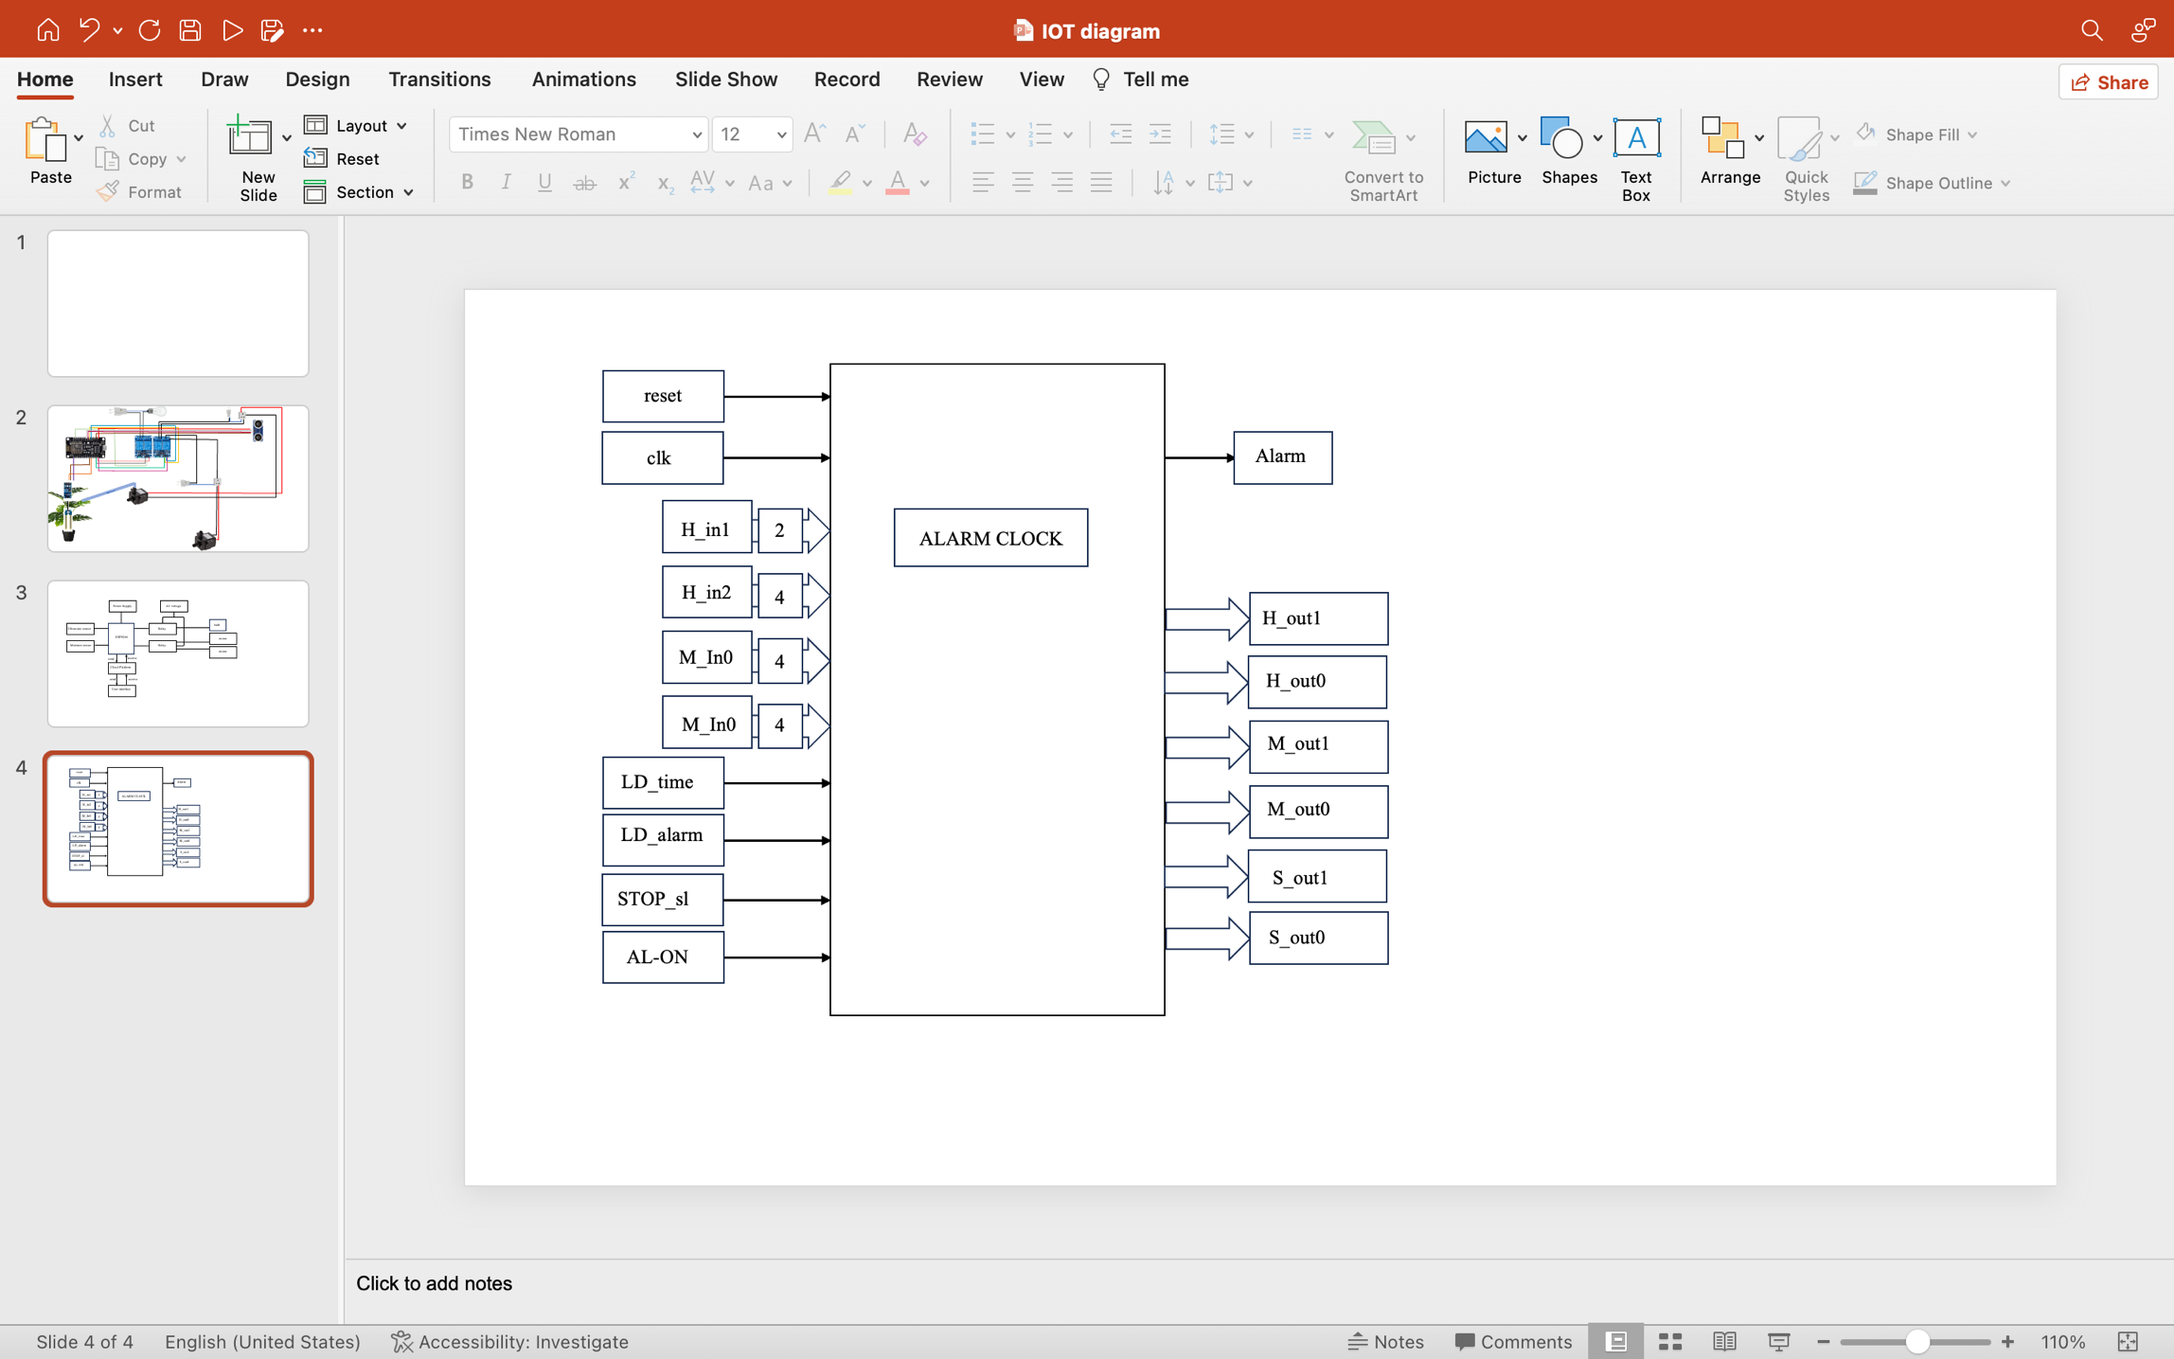

Fig 3.1 Block Diagram for Digital Alarm Clock

1. **System Flow Chart**

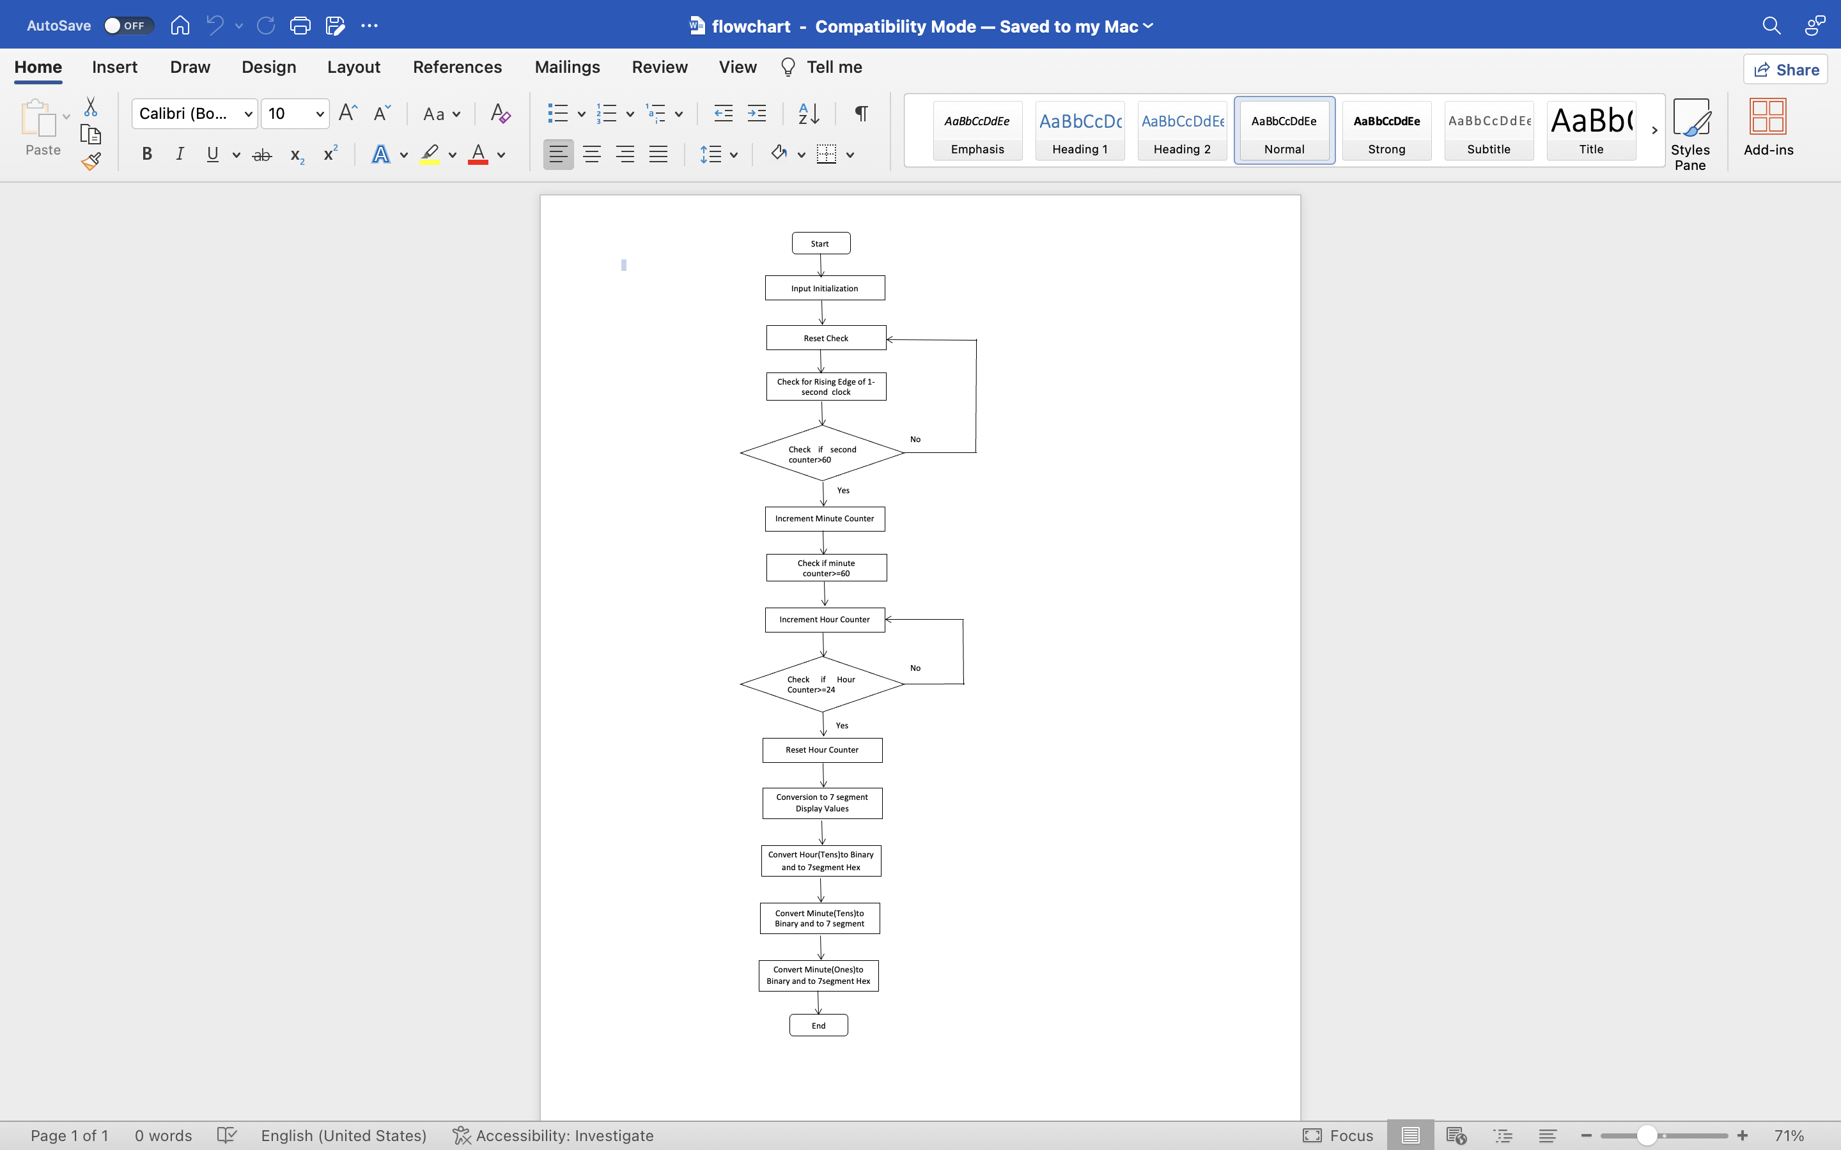

Fig 8.1 System flow chart for Digital Alarm Clock

1. **Simulation**

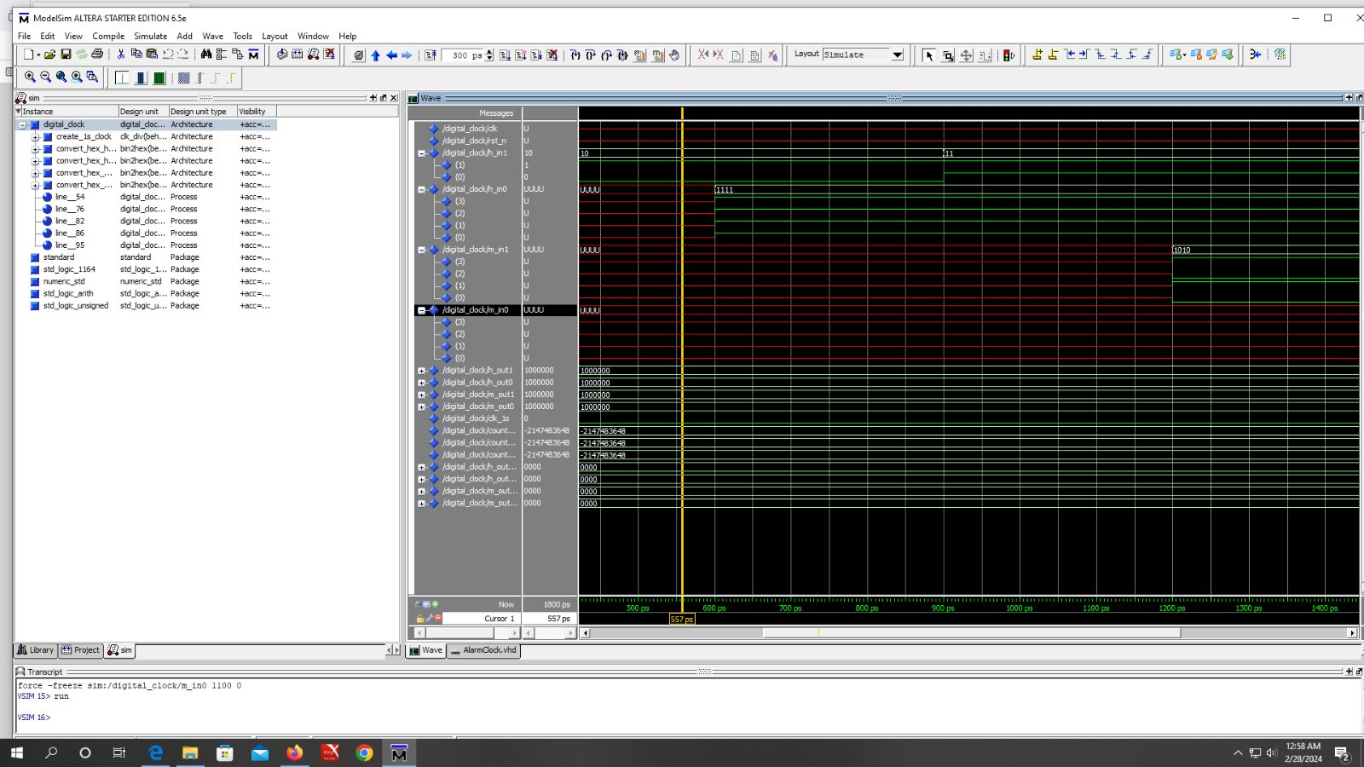

Fig 9.1 Output Result

1. **Architecture of Digital Alarm Clock**

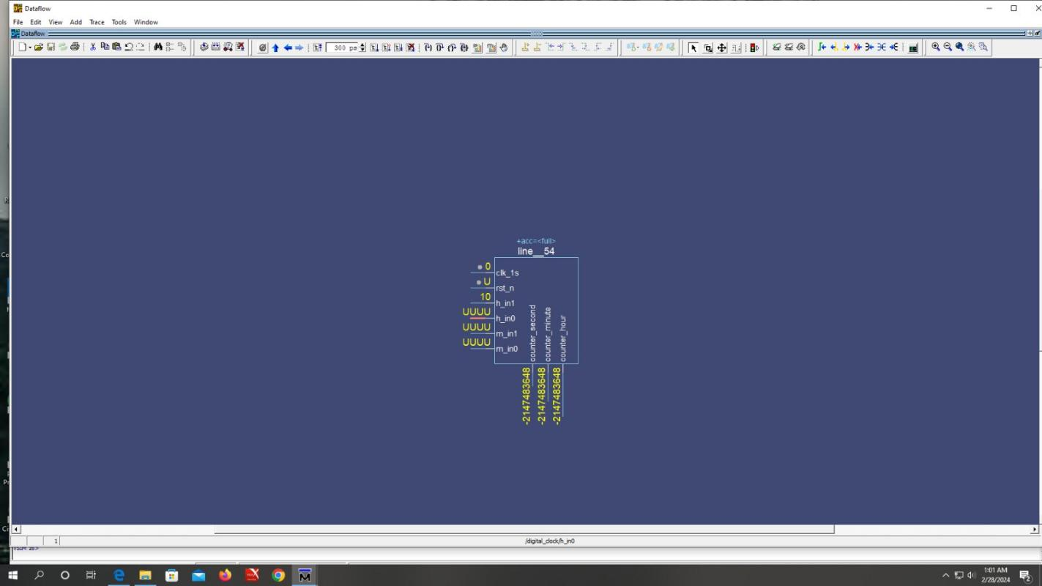

Fig 10.1 Architecture of Digital Alarm Clock

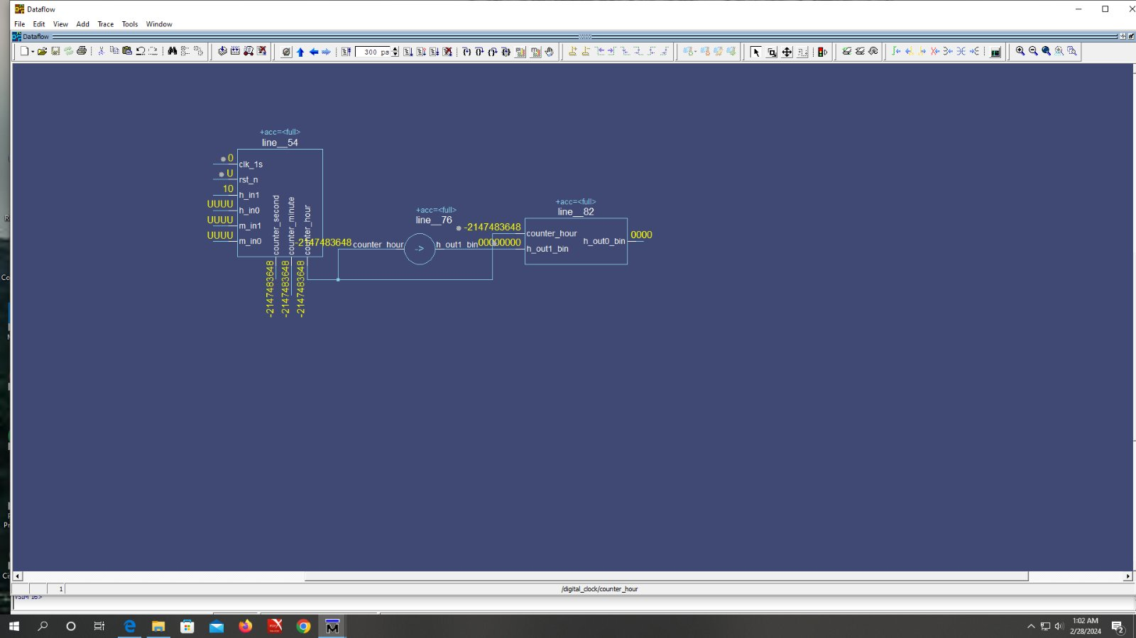

Fig 10.2 Architecture of Digital Alarm Clock for hour

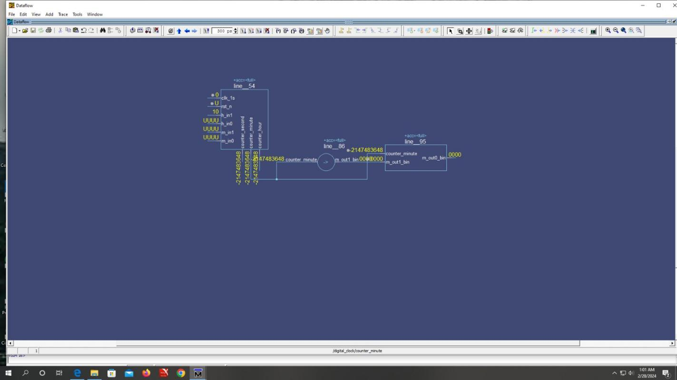

Fig 10.3 Architecture of Digital Alarm Clock for minute

**11.Advantages and Disadvantages**

**Advantages**

* Accuracy: Precise in displaying time, ensuring accurate wake-up calls
* Customization: Allowing users to personalize their wake-up experience
* Visibility: Digital displays are easier to read, especially in low light conditions

**Disadvantages**

* Power Dependency: rely on electricity or battery
* Limited Aesthetics: some users may find digital clocks less visual appealing

**12.Conclusions**

This system has become an essential part of modern life, offering convenience and reliability in waking up on time. Its compact design, ease of use, and customizable features make it a preferred choice for many people. Additionally, advancements in technology have led to the integration of additional functionalities such as radio and Bluetooth connectivity, enhancing its utility. Overall, this system continues to play a significant role in daily routine, ensuring punctuality and organization.

1. **Further Extension**

User Interface Enhancement: Add more user-friendly features to the interface, such as touchscreen functionality or voice activation, to make interacting with the clock more intuitive and convenient.

Alarm Customization: Implement advanced alarm customization options, such as setting different alarm tones or adjusting alarm volume levels based on user preferences.

Temperature and Humidity Display: Integrate sensors to measure temperature and humidity, and display this information alongside the time. This expands the clock's functionality and usefulness.

Internet Connectivity: Enable the clock to connect to the internet via Wi-Fi or Ethernet, allowing it to synchronize time with online servers and access weather forecasts, news updates, or online radio stations.

Mobile App Integration: Develop a companion mobile app that allows users to remotely control and configure the alarm clock, set alarms, and receive notifications on their smartphones.

Data Logging: Implement data logging capabilities to record and store historical data, such as alarm activation times or environmental conditions, which users can review and analyze.

Integration with Smart Home Systems: Integrate the alarm clock with popular smart home platforms like Google Home or Amazon Alexa, enabling voice commands and seamless integration with other smart devices in the home.

Power Management: Implement power-saving features such as automatic display dimming or sleep mode activation during periods of inactivity to conserve energy and prolong battery life for battery-operated clocks.

These extensions can add depth and sophistication to the digital alarm clock project, transforming it into a versatile and feature-rich device suitable for modern lifestyles.

**Web Site Lists**

* <https://github.com/saopayne/Digital-Alarm-Clock/blob/master/Alarm%20Presentation.pdf>
* <https://www.fpga4student.com/2016/11/vhdl-code-for-digital-clock-on-fpga.html>
* https://community.intel.com/t5/Intel-Quartus-Prime-Software/want-to-know-digital-alarm-clock-and-stopwatch-using-VHDL-coding/td-p/109014